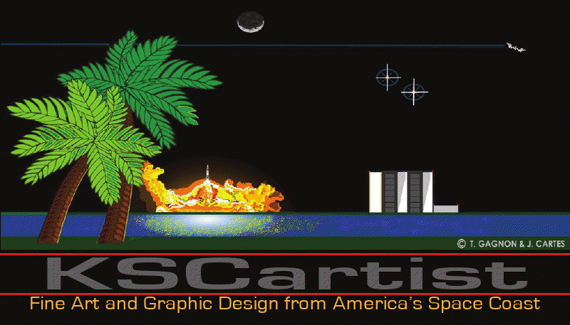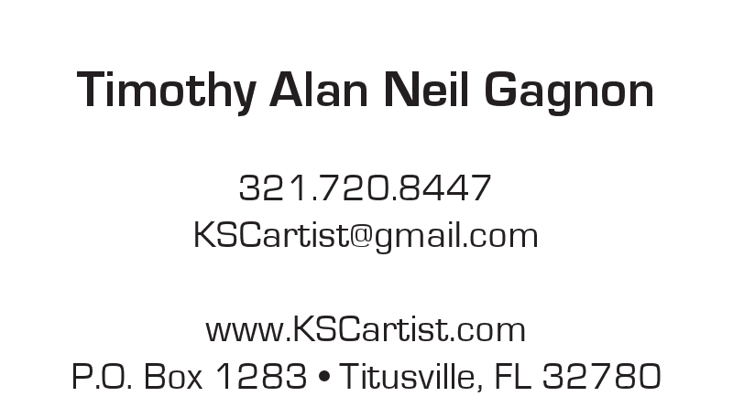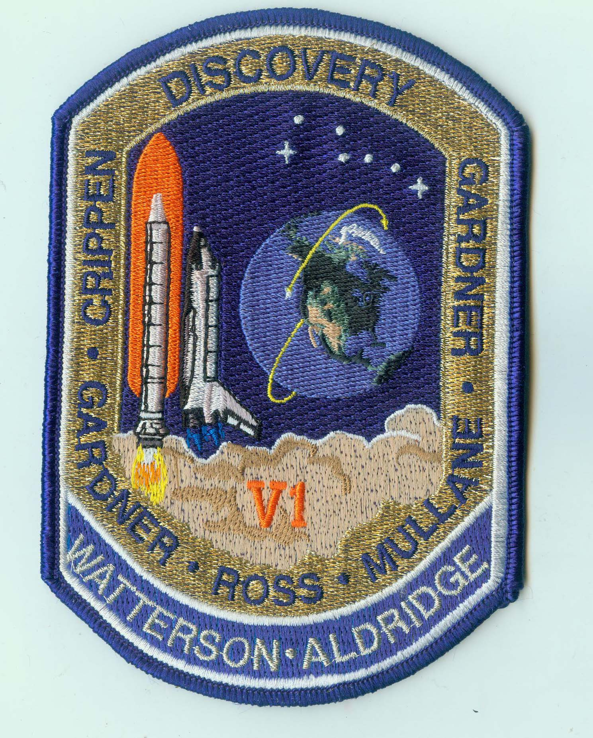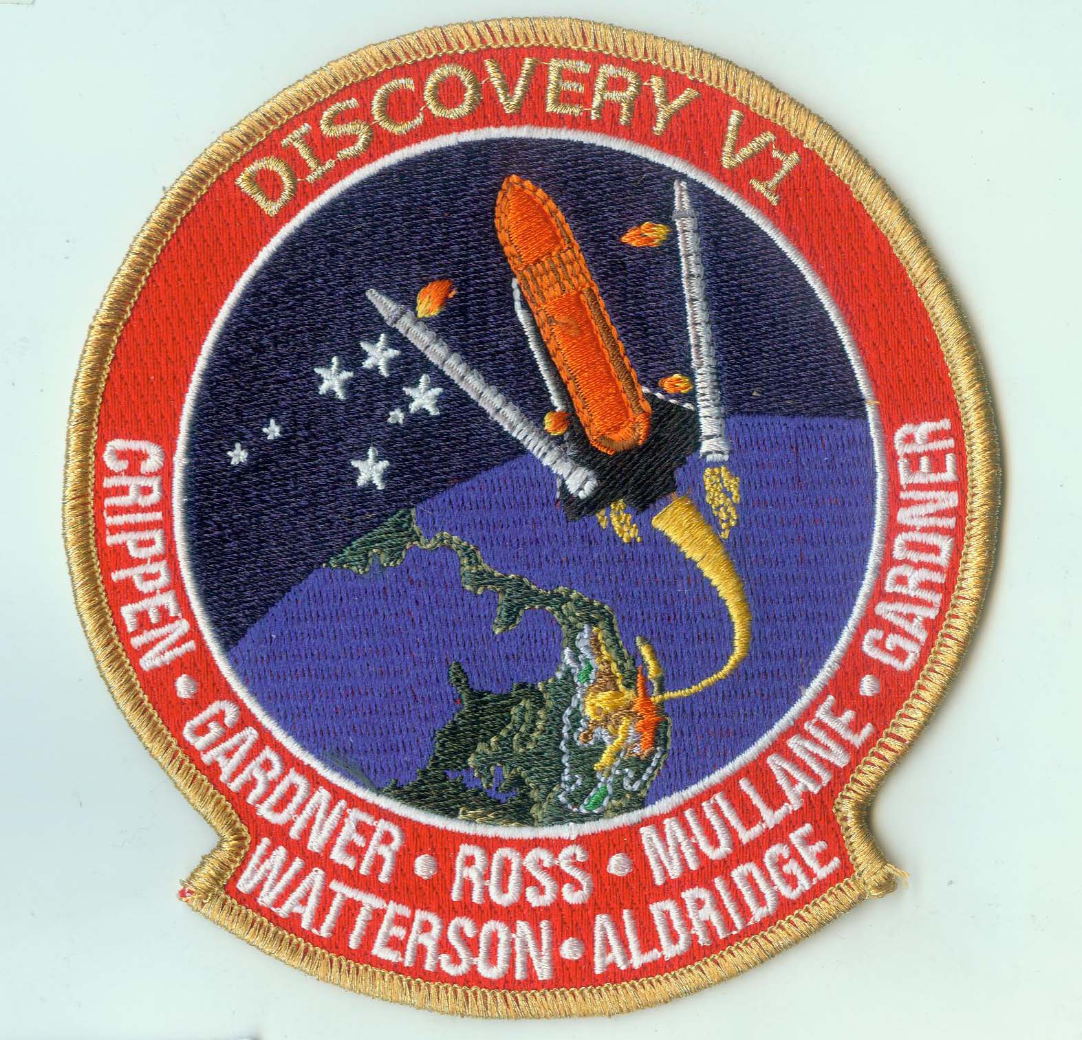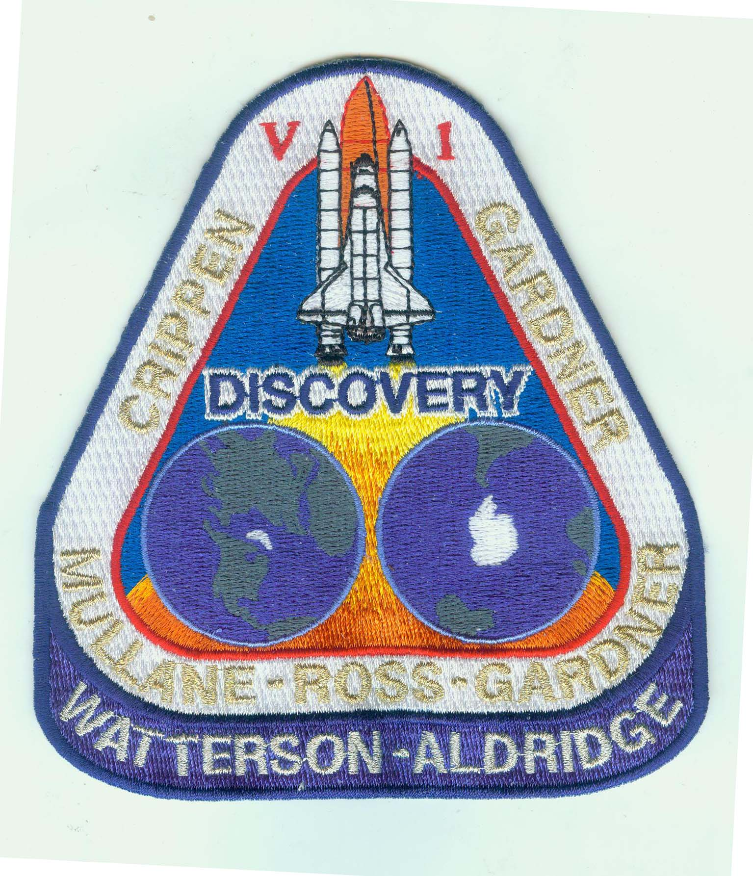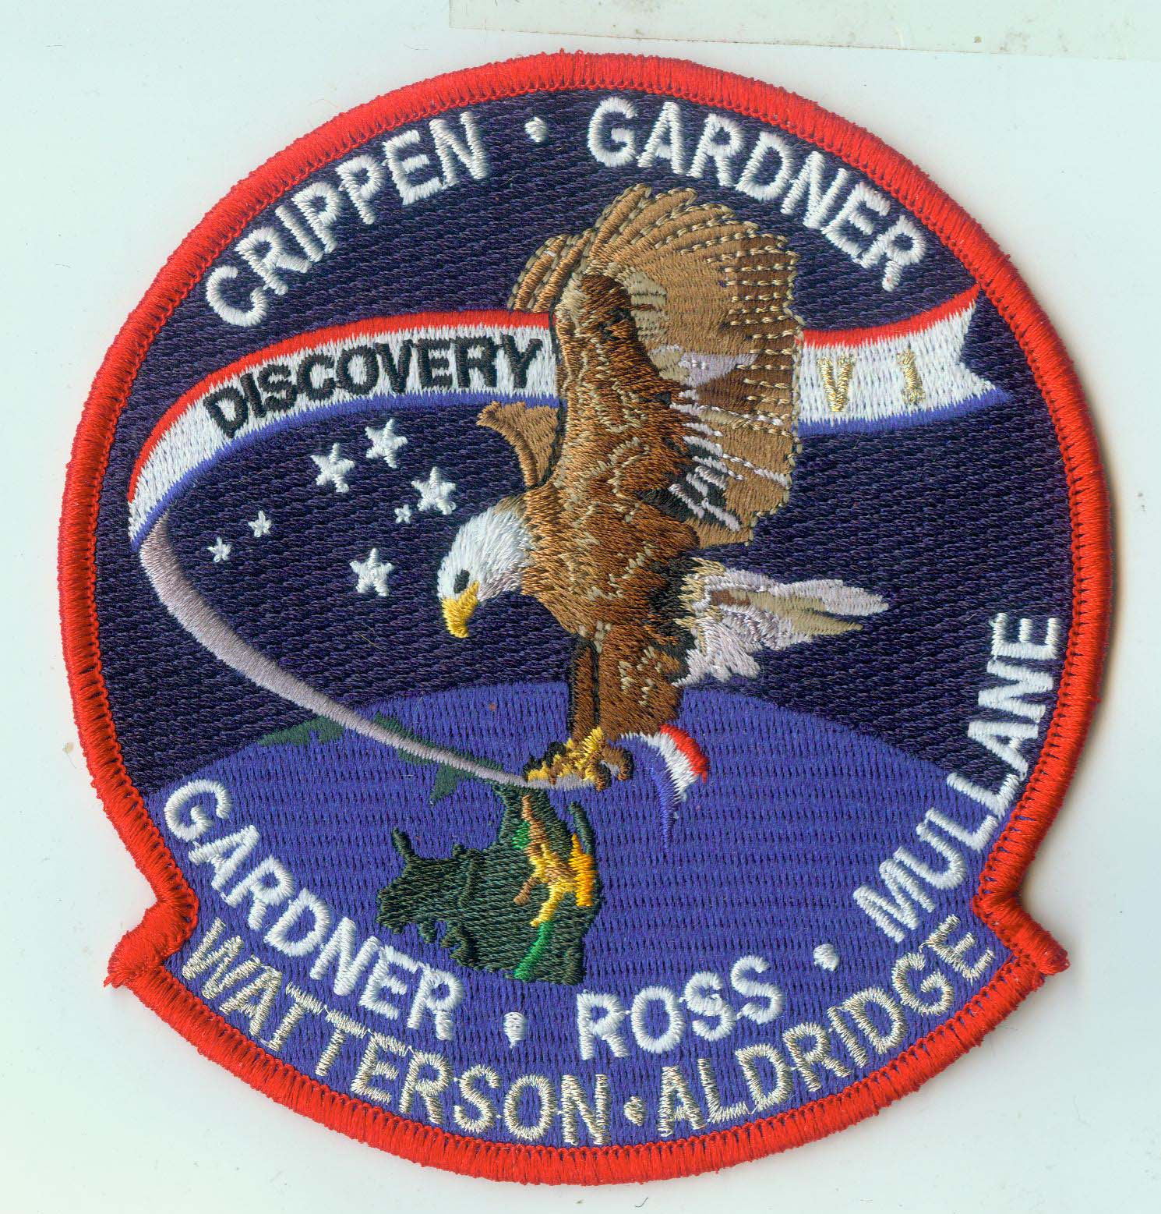
NEW PATCH ALERT 2014-7
STS-62A Draft Art Set

STS-62A Discovery V-1

This set is inspired by the first shuttle mission to launch from the Vandenberg AFB. On May 16, 1985 Bob Crippen responded positively to my request to help design their mission patch. I submitted four designs but the mission was canceled after the Challenger tragedy in 1986. These patches are updated versions of that original art – supposing that I had received feedback from the crew. For example in my original drawings, I had the orbiter launching north instead of south. In these patches the Payload Specialists names are included.

This design was created by Tim Gagnon of Titusville, FL and Jorge Cartes of Madrid, Spain.

Order NOW
Your price is $12.50/ea for the 4.5 inch patch or $10.00 each of you order all four.
Shipping via USPS Priority Mail - $10.00 domestic USA $25 for International. Orders can be combined.
This set will be offered one time. No more than 250 will be made.

Please print and send in this form along with your payment to:

Tim Gagnon
PO Box 1283
Titusville, FL 32780
Or you can pay via PayPal and add 6% to your total to cover fees or choose the “Friends and Family” option to avoid fees. If you choose this option please include your mailing address and email me this completed form.

Name_____________________________________________________________

Street ____________________________________________________________

City, State & Zip_____________________________________________________

Email: ____________________________________________________________

YOU MUST SUBMIT your PAID ORDER NO LATER THAN NOVEMBER 17, 2014.

Draft A Draft B Draft C Draft D

